Exhibition Proposal on African American Literary and Art works
Name
Institution

Abstract
My artwork will have an exhibition which portrays how slavery achieved numerous positive changes in the African American culture. This bondage has dependably been seen in an extremely negative note for the most part since it made wounds to the African people group. Wounds which have never healed to date in most of the African social orders living in America. This is normal since; human rights were abused and trodden on. However, this should not be transmitted to this generation of Africa-America.
In my artwork presentation, I intend to draw out the significance and beauty of slavery remembrance. Slavery made some constructive and lovely encounters and even substantial treasures and in additionally customs which individuals have adored up to date. My artwork paints bondage in a positive and beautiful picture which could never have existed if at all bondage did not occur.
As a component of positive effects of slavery, the beautiful African customs were exchanged to the American individuals. My artwork exhibition portrays this authenticity that was just being brought after slave trade happened. Diverse practices developed which are being passed on to generations. Celebrations of various cuisines, attire and even welcome and the advancement of dialect that was talked amid the slave exchange period.
Exhibition narratives
African American Literary and Artworks
Seton Hall University through the Walsh Gallery can open its understudies to wide learning openings through art. These learning openings can be accomplished through the depiction of the writing and visual specialties of the African-American people group. The importance of the topic is to depict the need of knowing an African and American culture. The nineteenth-century art about slave narratives will be demonstrated obviously to the group of viewers through this exhibition. As a teaching art presentation, specifically will enable students to comprehend historical aspects and African American society cultural practices to better due to the scholarly improvement they accomplish through art. Besides, the show brings to center this group of people and diminish the antagonism that occasionally is coordinated towards a decent number of people inside this piece of society.
Additionally, the importance of choosing this topic is to ensure that African and American appreciates the two cultures. The exhibition is mainly imperative particularly these days that racial pressure has enormously expanded. The need to bring the two groups together is essential to ensure more comfortable living together. The exhibition will also be of relevance through the connections that would have been made in the minds of the audience including the slave narratives that will have been brought clearly. The focus on the role of African Americans in the larger American society and what it means to be an American will reduce the disparity between the two groups. According to the mission, the gallery aims at enhancing the intellectual value of Seton Hall University and the greater community through dynamic, interdisciplinary exhibitions of excellent artistic and cultural value, which will have accomplished the aim of the presentation.
Artifacts that identify with African American art will be obtained from the Newark Museum and Brooklyn Museum which will be shown at the Walsh Gallery. They will incorporate sculptural photos, artworks, and important monuments. I will use car shipping to carry my objects to Walsh Gallery at Seton Hall University on the grounds because this form of transportation does not take more cost and sets aside a short opportunity for a conveyance. The art in the display informs the Seton Hall University's students regarding the one of a kind stories they tell about the lives and culture of African Americans. It will limit its setting to the mission of Seton Hall University where the more significant part of the display will be given in a way that improves the students and makes a better learning about African American expressions to the students.
The African-American experience will be shown on the artifacts where particular works of art will be utilized among the accessible objects. The painting will be picked with the end goal that they have pictures and pictures of how the Africans and Americans had relations during the slavery period. This approach will make the exhibition to be of significance to the audience where memoirs by individuals who had escaped from slavery will be utilized, for example, Frances Bok's book. The photo that will be used ought to be one that challenges the prejudice toward black people, which paints them as individuals not worth being acknowledged. The exhibition will be guided by a panel with the purpose of presenting the themes of the gallery.
Programs
The exhibition will be programmed by the artist that will be both directed at both students and the general public. The talk will be facilitated by the Curator Jeanne Brasile. There will also be six patrons that will be explaining about the African American literary works to the audience. Based on the theme, various books, pictures, paintings and the visual work will be displayed in the various sections in the gallery. The patrons will be placed each in every section to explain according to the theme the African American literary work.
The gallery management and all another aspect of curating will be discussed by the curator. The curator will also discuss the exhibition development with the students studying the fine art, art history, design or enrolled in gallery management class.
The sections will set on the various parts concentrating on the theme. The planning will be planned maybe starting with the pictures, and the patrons will be ready to explain the pictures by the theme to the guests. The monument or the painting can follow and every part of its patron to explain the various items displayed. Books will be set in their section where the guest will be viewing them and getting more information about the theme of the exhibition. The patron will also help in sharing this theme with the viewers. The visitors can pick the books to get more information by reading by themselves and getting more information about the theme of the exhibition. There will also a section of the monument, and the patron will be there to give information about the monument and the representation to achieving the theme of the exhibition. The visual arts will be another section that is set as the last. This will display the various videos on a screen. The audience will be sitting down watching the video that will be in line with the theme of the exhibition. The patron will explain the various parts of the video as the audience will be giving their various response and what they learn from the video.
Curator ensures effective working with the faculty and patrons so as to ensure correct interpretation of exhibition in context which facilitate varying curricula to the audience.
Target audience
The audience of the exhibition will be in the gallery and others will be far in various parts of the world. All these audience will be having access to the exhibition. Public relation will greatly help to ensure that those who are not in the gallery are able to access the happening in the exhibition.
The major target groups or audience of the exhibition are:
- Constituency of community members
- Faculty and staff members
- Students particularly the ones studying fine art and art history.
Artist and curator both have audience in Essex, Passaic and Hudson counties in New Jersey, Brooklyn and Manhattan.
Public relations
The exhibition will be having members from various parts of the world who will not be physically available for the exhibition. Such members will access our content due to the vigorous public relations that will be conducted. The public relations will be done through various ways which includes direct emails, direct post cards mailing, social media and press releases that are distributed to the individual, art blogs, specific art critics, curators and patrons.
Design
Production of the modest tri fold catalogue with perfect binding, a greater number of images and various essays whose source is curator and also from scholars and referencing the the work of the artist.
Video accompaniment will be there to ensure additional context in which to interpret the work that could be tailored meeting the curricula expectation. The professor will be encouraged to attend the exhibition so as to include it in the coursework. The artist talk will be recorded on video as a method of documentation of the exhibition. The video can be linked to online video streaming websites such as YouTube or Vimeo.

The Exhibition Budget“
DESCRIPTION | ITEMIZATION | SUBTOTAL | TOTALS
Gallery Preparation
Installation | O-Rings, Eyehooks,
Hardware | Anchors e.t.c | $200.00 | $200.00
Gallery Prep | Spackle, Sand Paper, etc. | $30.00 | $30.00
GALLERY PREPARATION SUBTOTALS |  |  | $230.00
Printed Material
Postcards | 5000 | $180.00 | $180.00
Postage | .35 x 2000 | $700.00 | $880.00
Posters | .40 x 50 | $20.00 | $900.00
Exhibition
Brochure | 500 pieces | $315.00 | $11950.00
Text Panel | 1 | $320.00 | $1515.00
Vinyl letter (Title) | 1 | $120.00 | $1635.00
PRINTED MATERIAL SUBTOTAL |  |  | $1635.00
Personnel
Artist Honoraria | Artist Talk + travel, time, expenses | $600.00 | $600.00
Curator Honoraria | Travel, time, expenses | $700.00 | $1300.00
PERSONNEL SUBTOTAL |  |  | $1300.00
Reception Food/Drink
Food Reception | 3 platters | $355.00 | $355.00
Wine - Reception | 75 x 3 | $225.00 | $580.00
Food/Drinks for attendees drink artist talk |  | $155.00 | $735.00
RECEPTION FOOD/DRINK SUBTOTALS |  |  | $735.00
THE EXHIBITION BUDGET |  |  | $3900.00

Floor plan
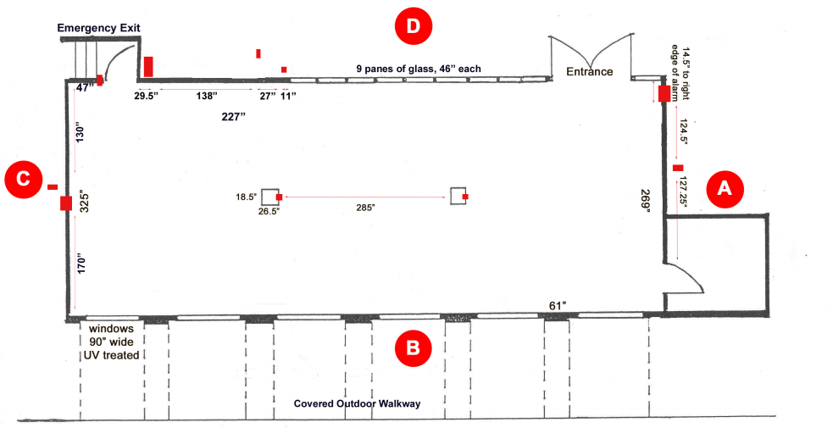


Exhibition timeline
The tasks are carried out chronologically as follows:
- Idea development
- Concept writing
- Target audience identification
- Working title identification
- Allocating tasks
- Collection material audit
- Non-collection material audit and development of budget
- Research
- Design layout
- Catalogue design
- Plan opening
- Install exhibition
- Opening and conducting programs
- Maintenance
- Demounting

Key staff
- Curator – the curator works as the overseer of the exhibition
Roles
- Contacting the artist and working with the artist to ensure collection of the resources to be used.
- Designing the structure of the exhibit
- Delegating construction and cleaning work to the staff members
- Ensure there is lighting, sound and views area
- Keeping exhibit on schedule
- Ensuring that the exhibition is under its budget
- Facilitating storage of the various resources such as artefact after exhibition
- Collection manager – their responsibility is basically managing the collections.
- Cooperates with the curator and other staff members to ensure exhibition work is done
- Retrieves the various collections from conservation upon curator’s request.
- Ensures establishment and standards of collections care, up to when to the display and back to conservation.
- Gives expenditure projection on the collections
- Facilitates cleaning of the various artefacts used and ensuring their condition is known.
- Gallery manager- basically these are the for the ensuring directions of the viewers and directing and giving information to those buying several artefacts
- Working with the artist and giving artist information about the forthcoming ,exhibition
- Ensuring visitors get information about the exhibition
- Managing gallery store and monitoring whatever goes out or in the store.
- He also deals with framer

Curator’s resume
Images
The following makes a list of representation of some of the picture that will be in the display.
